Draft Summary Report Cooper Jones Bicyclist Safety Advisory Council

Meeting #5, March 12, 2018, Yakima, WA
Participating: | Alex Alston; Barb Chamberlain; Dongho Chang; Charlotte Claybrooke; Chris Comeau; Aimee D’Avignon; Josh Diekmann; Steve Durrant; Marla Emde; Jessica Gould; David Jones; Liz Kaster; Rep. Shelly Kloba; Nancy Lillquist; Ofcr. Tim Martindale; Ofcr. Marc McPherson; Stacey McShane; Katherine Miller; Annette Nesse; Dr. Amy Person; Matthew Rollosson; Max Sevareid; Amy Shumann; Annie Szotkowski; Scott Waller.

Agenda Overview, February Meeting Review, Announcements
Scott thanked Annemarie Dufault from ESD 105 who arranged for the meeting room.
He said the revised 2017 Annual Report for the Cooper Jones Bicyclist Safety Advisory Council had been re-submitted to the Governor’s Office for review and approval.
Annie Szotkowski led a short discussion about possible activities for BSAC members travelling to Spokane to attend all – or part – of the Washington Bicycle Summit on April 29-30. The next BSAC meeting is scheduled of 5/1 at the Spokane Regional Health District. She said it would be possible to organize a group ride out to Spokane Falls Community College for the Summit or to organize a ride along the Centennial Trail after the summit, possible with an informal dinner in downtown Spokane. She also said she will be working with Katherine Miller and other Spokane-area BSAC members to organize a walking tour of planned bicycle improvement projects. More details to come.

Case Reviews – Ofcr. Tim Martindale presented the cases assisted by Staci Hoff, WTSC Research Director
There were five case reviews and then discussion after each. The summary of each case and a synopsis of the discussion about each case follows.

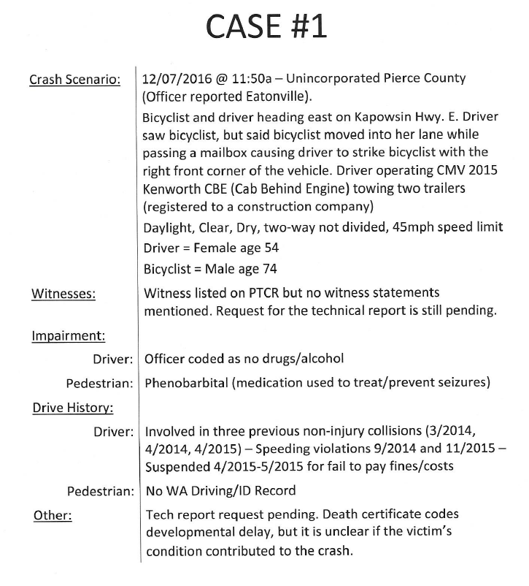 Observations/questions from Case #1:
  - Vehicle should have given more room;
- When there is no witness – and there is only the driver’s information available – there is very little information contained in the collision report;
- Onus should have been on the driver; she should not have been passing;
- Position of mailbox allowed room for bicyclist without them needing to swerve as reported by the driver
- Past legislative proposal was to allow for crossing double line to allow space for bicyclists if there was on oncoming traffic;
- Driver had multiple citations on her driving record as well as multiple reported collisions. Especially with collisions, the question that raises is whether the driver is a bad driver or whether that collisions happened because she is on the road so much. Five crashes in three years, including one since this fatal crash occurred;
- Reference to possibility of victim’s developmental delay in the collision summary was inappropriate. Staci Hoff said that information was on the death certificate from the coroner’s office.

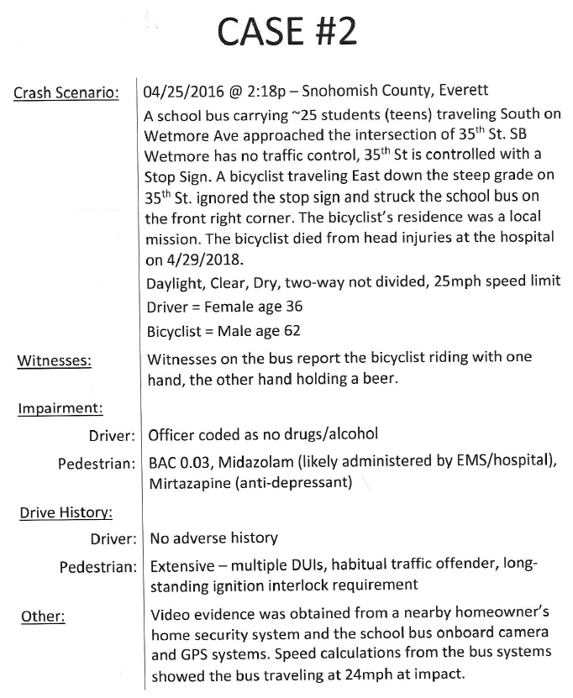 Observations/questions from Case #2:
  - Stacey – this area has heavy pedestrian traffic;
  - The shrubs on the corner may have kept the bus driver from seeing the bicyclist coming down the hill. There was discussion about who enforces rule for trimming hedges back on corners. Hedges and such are enforced by code enforcers;
  - Bicyclist had significant history of substance abuse, likely the bicycle was his only transportation after losing his license;
  - The intersection could be improved with curb extensions and signage.

  - 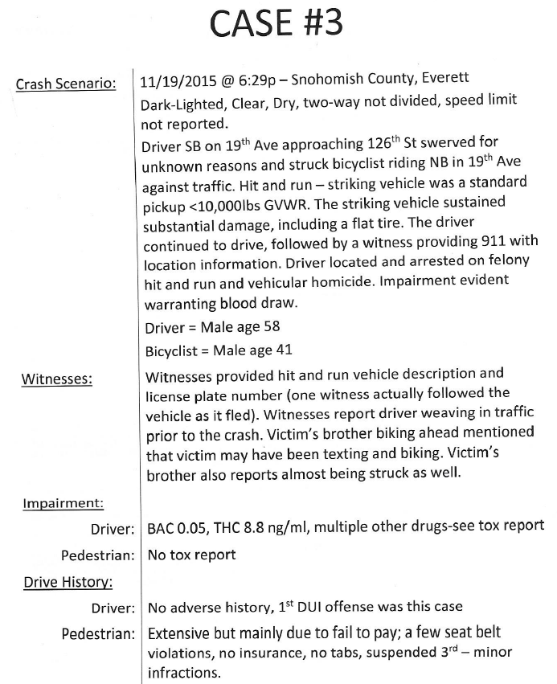
Observations/questions from Case #3:
  - Why was he riding on the wrong side of the road? There were not many areas to cross the busy road so maybe he was just staying on that side of the street to avoid needing to cross multiple times;
  - Drive had three different prescription drugs, including two sedatives on-board as well as marijuana;
  - Driver flat tire – did the flat tire happen with the crash or did it happen earlier?
  - T intersection where crash happened could be improved to incorporate complete streets design components including traffic calming or local jurisdictions not allowing development on both sides of the road;
  - State highway being used as surface transportation for people living in the area – example of impact of growth on existing infrastructure;
  - Driver had no insurance;
  - Bicyclists were two brothers. One was riding on the street, the other on the sidewalk. The one on the sidewalk was hit and killed by the impaired driver.
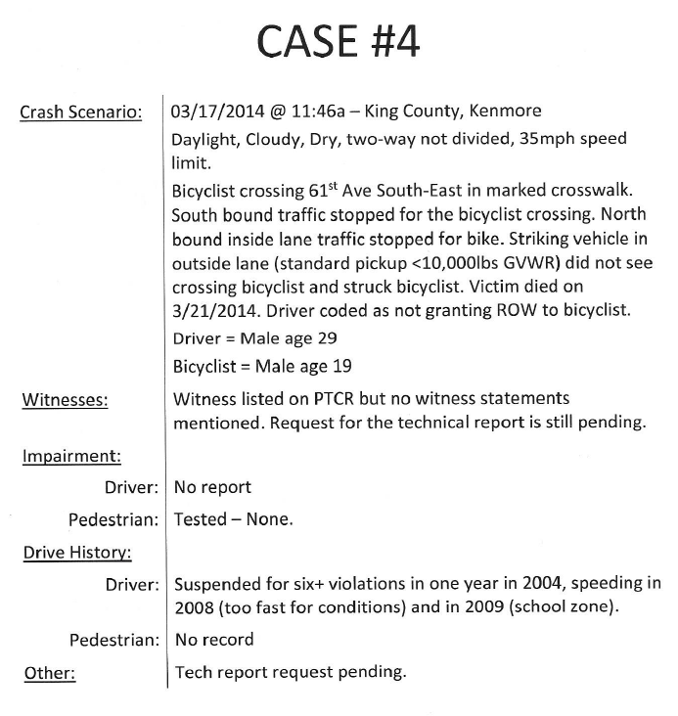 Observations/questions from Case #4:
  - Driver broke the law, failure to yield right of way;
  - There was a road diet implemented at the intersection after the crash; improvements were planned to get underway two weeks after the crash;
  - Was cyclist walking or riding bicycle in the crosswalk – doesn’t really matter because a bicyclist should be treated as a pedestrian if in the crosswalk;
  - Prosecutor chose not to use vulnerable user law although it clearly applied in this case. Under what circumstances could a prosecutor change a charging decision based on seriousness of injury?
  - Extensive violation record for driver;
  - Should we consider some other penalty system for collisions involving bicyclists and pedestrians?

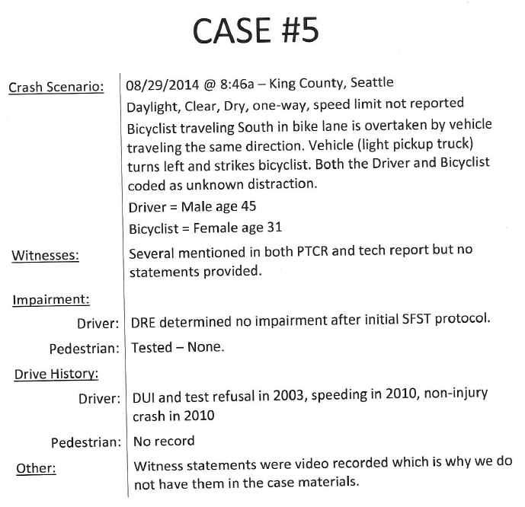 Observations/questions from Case #5:
  - There was an “unknown” distraction. Discussion over difficulty of citing for distraction. There is little that can be done to compel a search of a phone unless the driver volunteers their phone for law enforcement review;
  - It was unclear why the bicycle rider was reported to have a distraction although the information later became available that the driver was arguing with his girlfriend on his cell phone..
  - Driver said he was distracted and was fighting with his girlfriend;
  - There is a difference between how the site looks now and then. The two-way bike lanes were not installed at the time of the crash. Vulnerable user law was not implemented;
  - What kind of training is necessary for drivers of panel/box trucks – especially because of the reduced visibility?
  - Barriers on sides and rear of trucks can keep people from being swept underneath the truck;
  - Now that two-way bike lane is installed, are people
- Draft Recommendations based on case reviews:
- Failure to Yield needs more attention/infractions
- Need to emphasize Vision Zero principles
- Change state law to permit drivers to cross double yellow line to pass bikes with plenty of room if no oncoming traffic and they have sufficient line of sight to do so safely. This legislation was proposed a few years ago; review and update that.
- Infrastructure investments called for – traffic calming, road design, slower speeds, accommodations for all users, protected bike lanes and other separated facilities
- Address the connectivity and safety context created when development takes place on both sides of a state highway that transitions to a Main Street arterial; land use decisions by local jurisdictions affect state highways and create situations that require more design treatments and speed management.
- Emphasize “Transit-oriented development” instead of “Development-oriented transit”; that is, encourage development aimed at increasing density in more walkable, bikeable locations with transit service, rather than placing developments in settings where it is more difficult to extend comfortable walk/bike infrastructure and transit service and then asking that infrastructure/services be created.
- Strengthen vulnerable user law
- Study of ticket costs to see if it’s possible to set fines based on potential for injury, e.g. failure to yield is a very common reason for fatal/serious injury crashes but we don’t know how many tickets are issued or what the fines are.
- Educate on the importance of using turn signals before the turn
- More aggressive treatment by licensing and court systems of repeat offenders – especially regarding CDL holders
- Driver’s Education – emphasize mobility education by teaching driving, biking, transit use, and walking
- Require “Sideguards” on panel and box trucks operating in urban areas to keep people from being swept underneath the trucks
- Design for speed management – design slows movement
- Comprehensive evaluation of bicycling on state routes or crossing state routes
- More funding for infrastructure development and improvements for all ages and abilities
- Organize recommendations as short-, medium-, and long-term
- Design and implement alternatives to fines/infractions, diversion programs from traffic fines, especially in high poverty areas
- Extend implied consent law to cover distracted driving, e.g., you agree to turn over your phone for inspection or license suspension (would need to address concerns about other confidential information that may be on the phone like medical records, pictures, etc.)
- Where is the money for bicycle safety and how are we spending it now? Tabled to May 1 meeting.

