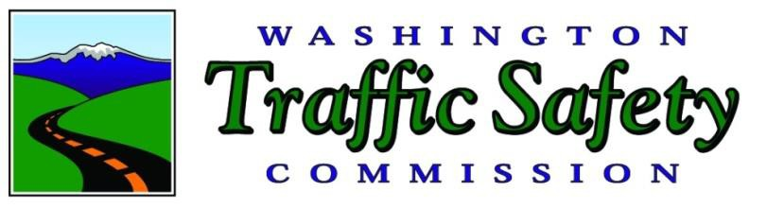

**COOPER JONES ACTIVE TRANSPORTATION**

**SAFETY ADVISORY COUNCIL**

2019 Annual Report

Darrin T. Grondel

Director

December 2019

**Publication and Contact Information**

A PDF version of this report is available for download on the Washington Traffic Safety Commission website at: <http://wtsc.wa.gov/>

**For questions/information, please contact:**

Scott Waller   
Program Manager

Washington Traffic Safety Commission

PO Box 40944

Olympia, WA 98504-0944

Phone: (360) 725-9885

Email: [swaller@wtsc.wa.gov](mailto:swaller@wtsc.wa.gov)

**For policy-related questions/information, please contact:**

Shelly Baldwin

Legislative and Media Director

Washington Traffic Safety Commission

PO Box 40944

Olympia, WA 98504-0944

Phone: (360) 725-9889

Email: [sbaldwin@wtsc.wa.gov](mailto:sbaldwin@wtsc.wa.gov)

**Table of Contents**

Introduction 4

ATSAC Purpose and Scope 7

2019 ATSAC Accomplishments 7

Progress Made on Recommendations from PSAC and BSAC 8

Key Language Use Concepts from BSAC and PSAC Reports 22

Crash Data for People Who Walk or Ride Bicycles: A Deeper Look 23

Appendix A – Cooper Jones Active Transportation Safety Advisory Council Project Charter 29

Confidentiality Statement 35

Introduction  
  
**Creation of the Cooper Jones Active Transportation Safety Council**  
In 2019, the Washington State Legislature passed Substitute Senate Bill 5710, creating the Cooper Jones Active Transportation Safety Council (ATSAC). The purpose of the council is to review and analyze data to identify patterns and programs related to fatalities and serious injuries involving people who walk, ride bicycles, or use other forms of active transportation to identify points at which the transportation system can be improved including, whenever possible, privately owned areas of the system such as parking lots.  
  
**Related History of Cooper Jones Bicyclist Safety Advisory Council and Pedestrian Safety Advisory Council**

Deaths for people who were walking or biking are at the highest number in more than 30 years. Nearly one-quarter of all traffic fatalities and 20 percent of all traffic serious injuries in our state were people who were walking or biking.

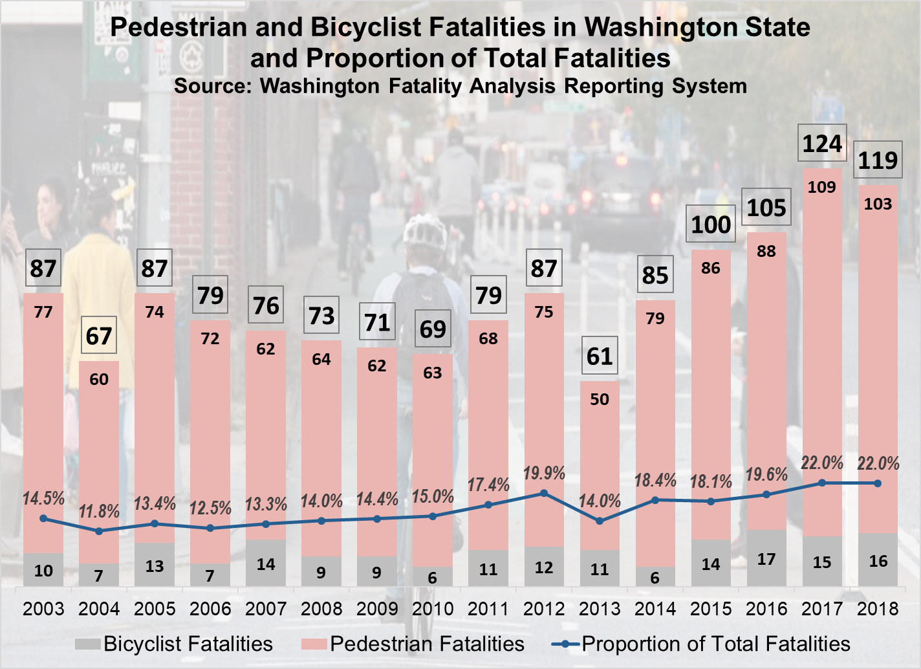

Each statistic represents a person and, in the case of a fatality, a person no longer able to do the things they enjoyed in life. Some victims were longtime members of their communities. Many had spouses and children. Among the deceased are retired people, teachers, truck drivers, faith leaders, and youth sports coaches. Some were walking to public transit bus stops or to the grocery store. Many walkers who died lived in low-income neighborhoods and walking was their primary form of transportation.

It is within this context that the Washington State Legislature established the Pedestrian Safety Advisory Council (PSAC). Substitute Senate Bill 5957 charged the council to examine crashes and recommend changes that would improve the safety of these vulnerable road users. The group met 25 times and submitted three annual reports to the Washington State Legislature with recommendations for improving safety for people who walk.

In 2017, the Washington State Legislature voted to re-establish the Cooper Jones Bicyclist Safety Advisory Council (BSAC), to analyze data about fatalities and serious injuries throughout the state for people riding bicycles, and identify opportunities for safety improvements. Substitute Senate Bill 5402 (2017-18) established the first interdisciplinary panel dedicated to examining causes of serious injury and death for people who bike and providing subsequent recommendations for prevention to the Legislature.

This effort brought together people and perspectives from transportation engineering, public health, education, law enforcement, emergency services, local and tribal governments, and bicycle advocacy for a multi-disciplinary, multi-agency approach to the public health issue of fatalities and serious injuries for people riding bicycles. The BSAC was first created by the Washington State Legislature in 2017.The council met 18 times and submitted two annual reports to the Washington State Legislature with recommendations for improving safety for people who ride bicycles.

Combining the two councils provides an opportunity to use prior efforts as a launching point and to gain energy and synergy for the newly combined council from former members of the separate councils. Additionally, creating a new council provides the opportunity to recruit new members who represent a wider array of knowledge and backgrounds. In addition, by not imposing a sunset clause on the ATSAC, the Legislature also recognized that safety promotion for people who walk, ride bicycles, or use other forms of active transportation is ongoing and should not end until the work is done.

**Target Zero Priority for People Who Walk or Ride Bicycles**

The 2019 update to Washington State’s Strategic Highway Safety Plan - Target Zero – establishes people who walk or ride bicycles as one of the state’s highest priority populations for traffic safety efforts. Nearly one-quarter of the state’s traffic fatalities involve active transportation or people who are using non-vehicle modes.

Target Zero is a data-driven strategic plan used to identify priorities and solutions, help create common goals, and develop common language so we can work together across disciplines. Target Zero is built on the belief that not one death is acceptable on our state’s roadways. Everyone in Washington should be able to travel our roadways without the fear of being killed or seriously injured in a traffic crash.

# ATSAC Purpose and Scope

In 2019, Substitute Senate Bill 5710 established the ATSAC to “review and analyze data points at which the transportation system can be improved, and identify patterns in pedestrian (people who walk) fatalities and serious injuries.”

The Washington Traffic Safety Commission (WTSC) convened the ATSAC on September 18, 2019. Members include experts from multiple disciplines including law enforcement, traffic engineering, traffic safety, public transit, injury prevention, cities, counties, tribes, and the King County coroner. The council meets every other month to review data about people who walk, bicycle, or use other forms of active transportation to compile evidence on actions that Washington can take to prevent deaths and serious injuries.

The council’s purpose is to decrease fatalities and serious injuries among people who walk, ride bicycles, or use other active transportation. To accomplish this, the council is directed to:

* Review and analyze crash data.
* Identify points at which the transportation system can be improved.
* Identify patterns in fatalities and serious injuries involving people who walk, ride bicycles, or use other forms of active transportation.
* Recommend changes in statutes, ordinances, rules, and policies to improve safety for people who walk, ride bicycles, or use other forms of active transportation.

The council will address its recommendations to organizations with the authority to implement, including the:

* Appropriate state agencies
* Governor’s Office
* Washington State Legislature House and Senate Transportation Committees

While some actions are possible using existing authority and interagency collaboration, it is expected that others will require expanded authority and/or new funding.

# 2019 ATSAC Accomplishments

2019 accomplishments include the following:

* Reorganized membership of ATSAC from the previous two councils (PSAC and BSAC) to include representation from disabilities, racial/ethnic, elderly, and low-income groups.
* Formed an Executive Committee that provides oversight and direction for the council, designs agendas, and manages the budget.
* Developed a new project charter that includes new elements as well as some elements from the former PSAC and BSAC charters. (Appendix A)
* Developed a set of operating rules and protocols. (Appendix A)
* Provided input into the update of Washington’s Active Transportation Plan during the November 2019 meeting.
* Participated in a “Pedestrian and Bicyclist Program Assessment” conducted by the National Highway Traffic Safety Administration (NHTSA).
* Members provided input to the WTSC about distribution of more than $300,000 in federal funds and $250,000 in state funds to address safety for people who walk, bike, or use other forms of active transportation.
* Participated in the development and launch of Washington’s update to the Active Transportation Plan.
* Members developed an active transportation supplement for the Washington State Strategic Highway Safety Plan, Target Zero 2019 Update.
* Washington State Department of Transportation (WSDOT) established the Injury Minimization Speed Management Policy Work Group to provide guidance to local jurisdictions about best practices for setting speeds on roadways. The work group was a recommendation in both of the 2018 BSAC and PSAC reports.
* Funding for operation of the Cooper Jones ATSAC passed the Washington State Legislature and was signed into law by Governor Jay Inslee.
* Changes to Washington’s Vulnerable User Law and directions for drivers encountering people riding bicycles on two-lane roads passed the Washington State Legislature and was signed into law by Governor Jay Inslee.

# Progress Made on Recommendations from PSAC and BSAC

The 2018 PSAC and BSAC Annual Reports both used five internationally recognized principles of sustainable safety to categorize their recommendations. The groups added a category for recommendations that cross into multiple safety principles.

The principles of sustainable safety (Vision Zero) were developed in Europe and many United States cities have adopted them. Traffic safety performance improvements have occurred in areas where the principles of sustainable safety have been fully implemented. Vision Zero starts with the conviction that everyone has the right to move safely in their communities.

The Vision Zero approach recognizes that people will sometimes make mistakes, so 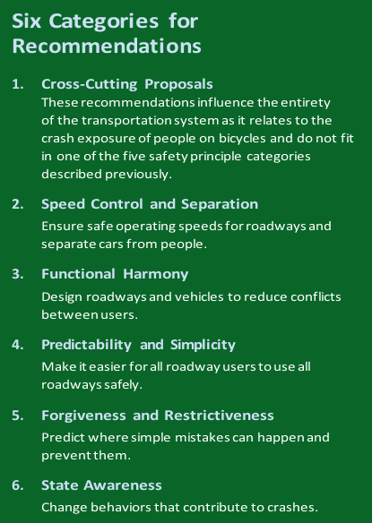transportation system designers and policymakers must improve the roadway environment, policies (such as speed management), and other related systems to lessen the severity of crashes. (Vision Zero Network, n.d.)

Deliberations by the BSAC and PSAC in 2018 did not address every principle at the same level of detail and this work continued with the ATSAC in 2019. In its ongoing work the council will continue to develop recommendations for improving safety for people who walk, bike, or use other forms of active transportation based on continuing examination of information associated with each of the principles.

You will see the following symbols as you read through the recommendations:

|  |  |
| --- | --- |
|  | = This symbol indicates the recommendation applies to people who walk (pedestrians). |
|  | = This symbol indicates the recommendations applies to people who ride bicycles (bicyclists). |

Cross-Cutting Proposals - These recommendations influence the entirety of the transportation system as it relates to people who walk or ride bicycles.

|  |  |  |  |
| --- | --- | --- | --- |
| **Recommendation from 2018 BSAC or PSAC Reports** | **Applies to** | | **Status** |
| Convene a statewide Active Transportation Safety Advisory Council (ATSAC). |  |  | SSB 5710, creating the ATSAC, passed the Washington Legislature in 2019 and Governor Jay Inslee signed the bill into law. The group met for the first time in September 2019. |
| Improve data systems and coordination. |  |  | WSDOT is currently reassessing how and where to place devices to count people who walk or ride bicycles (counters).  WSDOT and WTSC are working on a research project to determine the efficacy of developing a system to estimate the number of people who walk, bike, or use other forms of active transportation using “crowdsourced data.”  The State Active Transportation Plan (ATP) – currently in development - will produce a network analysis method to identify potential statewide demand for safe active transportation. |
| Convene a work group to establish priorities for walker-friendly infrastructure investment. |  |  | Further discussion of this issue will be part of the 2019-20 ATSAC work plan. |

Safety Principle 2 - Speed control and separation: Ensure safe operating speeds for roadways and separate cars from people.

|  |  |  |  |
| --- | --- | --- | --- |
| **Recommendation from 2018 BSAC or PSAC Reports** | **Applies to** | | **Status** |
| Develop target speed policy for use at all jurisdictional levels. |  |  | WSDOT has organized the Injury Minimization Speed Management Policy Work Group that administered and analyzed a survey for engineers in the state regarding setting of speed limits.  The group plans to have draft policy for distribution by the end of 2019. Information will be on [WSDOT’s “Pedestrian Safety in Washington” webpage](https://www.wsdot.wa.gov/travel/commute-choices/walk/pedestrian-safety). Trainings to support the implementation of the speed management policy and guidelines will be developed and delivered in 2020. |
| Allow automated speed enforcement in school walk areas. |  |  | Legislative action is needed to further address this issue.  The House Transportation Committee held a public hearing about automated enforcement in the final weeks of the 2019 session. |
| Designate revenues from automated enforcement for safety improvements. |  |  | Legislative action is needed to further address this issue. |

Safety Principle 3 - Functional Harmony: Design roadways and vehicles to reduce conflicts between users.

|  |  |  |  |
| --- | --- | --- | --- |
| **Recommendation from 2018 BSAC or PSAC Reports** | **Applies to** | | **Status** |
| Increase training regarding integration of transportation and land use. |  |  | WSDOT Active Transportation Programs Division (ATD) and Local Programs Division Training is designing training on systematic safety approaches and Target Zero.  Metropolitan planning organizations and regional transportation planning organizations will use updated Target Zero 2019 goals in their planning and reporting.  The ATP will also provide tools for a network analysis on state right-of-way and project prioritization framework to assist in this. |
| Incorporate health and safety considerations into updates of Washington State’s Growth Management Act. |  |  | Legislative action is needed to further address this issue.  In June 2019, the University of Washington’s William D. Ruckelshaus Center released its long-awaited report evaluating Washington State’s Growth Management Act and other laws regulating or directing growth in the state. The Center’s report, *A Roadmap to Washington’s Future*, includes recommendations to improve the state’s planning regulations and policies.  One key recommendation was to incorporate a new goal that would address human health and well-being as a goal in growth management planning and implementation, including the design and location of transportation and other infrastructure, land use plans, and development of regulations. |
| Consider all roadway users in autonomous vehicle planning. |  |  | Changes to existing state law would be necessary to address this issue.  The Governor’s Autonomous Vehicles Work Group has adopted the consideration of all roadway users as a priority focus for testing and operation of autonomous and connected vehicles. |
| Require autonomous vehicles to follow rules of the road. |  |  | Legislative action is needed to further address this issue. |

**Safety Principle 4 - Predictability and Simplicity: Make it easier for all roadway users to use all roadways safely.**

|  |  |  |  |
| --- | --- | --- | --- |
| **Recommendation from 2018 BSAC or PSAC Reports** | **Applies to** | | **Status** |
| Increase investment in infrastructure in underserved areas. |  |  | The ATP (under development) will include a project prioritization framework that incorporates equity as an element to prioritize underserved areas. |
| Develop statewide bicycle network over 10 years. |  |  | The ATP includes a framework that prioritizes projects in underserved areas, a network analysis of state right-of-way that identifies the level of stress for the person riding a bicycle and priorities for improvement, and will incorporate projects identified through regional plans as part of the statewide needs assessment in the plan.  WSDOT is incorporating US Bicycle Route (USBR) identification work into regional plans and projects as opportunities arise. Preliminary identification of possible USBR20 (northern-most east/west USBR in Washington) began at the 2019 Washington Bike Summit. |
| Support technology to improve safety for people who walk. |  |  | WSDOT’s Americans with Disabilities Act Transition Plan includes a requirement to inventory assets including signals that are accessible for people who walk.  The “WSDOT Pedestrian Crossing Safety Action Plan” includes recommendations for use of “Leading Pedestrian Intervals” and other technology elements for improving safety for people who walk. The Traffic Manual was updated in 2019 to incorporate recommendations from that plan.  WSDOT has a research project with the University of Washington Smart Transportation Applications and Research (STAR) Lab to develop and test a mobile phone-based application that would enable people who walk, bike, or use other forms of active transportation to activate a traffic signal as they approached it so the walk sign can be triggered before they reach the intersection. This is part of WSDOT’s overall work on Intelligent Transportation Systems technology to support a multimodal transportation system. |
| Transit systems add criteria to transit stop siting considerations. |  |  | Further discussion of this issue will be part of the ATSAC work plan. |

**Safety Principle 5 - Forgiveness and Restrictiveness: Predict where simple mistakes can happen and prevent them.**

|  |  |  |  |
| --- | --- | --- | --- |
| **Recommendation from 2018 BSAC or PSAC Reports** | **Applies to** | | **Status** |
| Strengthen and update the vulnerable user law. |  |  | SSB 5723, the “Vulnerable User Law,” passed both houses of the Washington Legislature in the 2019 Washington State Legislative Session and Governor Jay Inslee signed the bill into law. |
| Authorize bicycle traffic signals. |  |  | Legislative action is needed to further address this issue. |

**Safety Principle 6 - State Awareness: Change problem behaviors.**

|  |  |  |  |
| --- | --- | --- | --- |
| **Recommendation** | **Applies to** | | **Status** |
| Research development impact fees and other topics. |  |  | This work has been added to the ATSAC work plan. |
| Update school walk areas statewide. |  |  | Further discussion of this issue will be part of the 2019-20 ATSAC work plan. |
| Include active transportation in driver education. |  |  | Multiple efforts are underway to improve the curriculum used to teach novice drivers.  The Washington Driver Guide was updated in 2019 to include much more information on issues affecting people who walk, bike, or use other forms of active transportation.  Washington became the third state in the US to include a recommendation to use “Dutch Reach” to prevent “dooring[1].” |
| Revise lane restrictions for passing. |  |  | Clarified as part of SSB 5723, passed by the 2019 Legislature and signed into law by Governor Jay Inslee. |
| Implement statewide awareness campaigns to improve safety for people who walk. |  |  | Piloted a statewide awareness campaign focused on improving safety for people who walked to Seattle Mariners games in May and June 2019.  In 2019, several Washington cities – including Bellingham, Everett, Lynnwood, Mountlake Terrace, Seattle, Spokane, and Vancouver – implemented awareness campaigns to improve safety for people who walk. |

**Key Findings from PSAC and BSAC Work**

**Finding #1 - Vehicle operating speed determines severity of injuries and driver response**

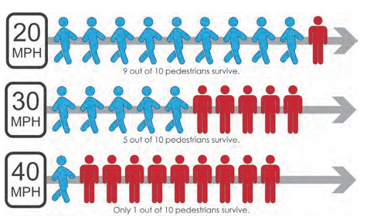Creating road environments where people are safe from crashes means dealing with the speed of vehicles. The likelihood of crashes decreases markedly when drivers slow down. When they slow down, drivers have more time to pay attention to what is going on around them. Operating speeds need to be consistent with the local land use context, with speeds slowing as urban access and density increases. In other words, the more vehicles and the more people, the slower the appropriate operating speeds should be. The chart to the right shows the relationship between operating speed and percentage of crashes resulting in a fatality at each posted speed limit when crashes occur. The posted speed is often used as a proxy for the speed at which drivers were traveling because it is difficult to determine the actual speed of a vehicle involved in a crash. The potential for a fatality involving a person who is walking increases rapidly for crashes involving vehicles going 30 mph or faster. Most crashes between people driving vehicles and people walking occur in areas with posted speeds of 35 mph or less. This intuitively makes sense since a significantly higher number of people walk on streets in cities and towns, including some state routes that serve as principal arterials.

Safe Systems is an approach to road safety management, based on the principle that our life and health should not be compromised by our need to travel. Safe Systems improvements focus on vulnerable road users such as people who walk, ride bicycles, or use other forms of active transportation. Designing roadways to reduce exposure to potentially fatal crashes for the most vulnerable road users is a proven, effective strategy to achieve better outcomes for motorists and motorcyclists as well. WSDOT has proven the efficacy of this approach through its existing programs, such as ongoing efforts to reduce rural run-off-the-road crashes for motorists.

In this type of approach, WSDOT examines the roadway system to identify features that research has shown are more likely to result in crashes. These might include certain curve types, the speeds the roadway was designed to carry as compared with the posted operating speeds, or other aspects of the roadway and its usage. Engineers use this information to determine locations to implement countermeasures or strategies to proactively reduce the chances that a crash will occur for the given crash patterns and crash types at a given location.

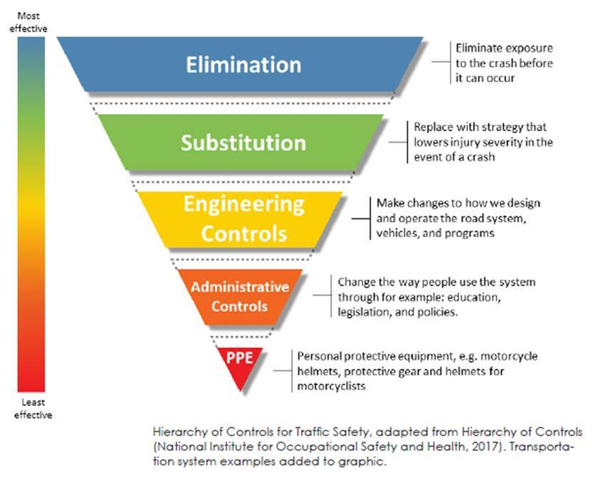

WSDOT convened an Injury Minimization Speed Management Work Group, as recommended in both the 2018 BSAC and PSAC annual reports, to develop some clear recommendations for local jurisdictions about designing roadways to carry appropriate speeds. The work group is scheduled to deliver a policy for use by local jurisdictions by the end of 2019. However, development of a policy is difficult because the contexts for roadway use make a one-size-fits-all speed policy challenging to develop or implement. Local and historical expectations about use of roadways can conflict with a goal of increasing safety by reducing operating speeds.

Most people agree that people should not walk along interstate highways because of the high speeds and the fact that the roadways are not designed to provide any protection for walkers. Similarly, it is dangerous for people who walk, ride bicycles, or use other forms of active transportation to use state highways that go through urban areas unless there is a significant reduction in speed and, preferably, other design features that separate people who walk, ride bicycles, or use other forms of active transportation from vehicle traffic. Many rural or county roads present elevated crash risk for people who walk, ride bicycles, or use other forms of active transportation because they were designed for speeds of 45 mph or more when they were first built. However, because of growth and significant increases in vehicle traffic, those posted speeds need to be reduced to increase safety for people who walk, ride bicycles, or use other forms of active transportation and drivers. There are also issues with “urban collector” roads that can have speeds up to 35 mph. Those roadways present elevated crash risk exposure for people who walk, ride bicycles, or use other forms of active transportation unless speeds are reduced or there is additional protected separation provided between vehicle traffic and people who walk, ride bicycles, or use other forms of active transportation. In Washington, cities have the option of reducing speeds to 20 mph in residential areas where many people who walk, ride bicycles, or use other forms of active transportation utilize the roadways. However, so far, few cities have chosen to do that. In most cases, the impediment to reducing speed limits is local and historical expectations of those roadways.

Considering the context of roadway use represents a shift to focus on the most effective countermeasures to reduce crash exposure for everyone, which is an evolution from a system oriented primarily around modes or numbers of specific types of users.

Unfortunately, much of the current efforts to promote safe transportation systems focus on things that the user can do like wearing light-colored clothing at night or using bicycle helmets. While those are both good practices, they are among the least effective strategies for preventing fatalities and serious injuries.

Using data-driven safety analysis helps engineers identify locations, specific treatments, and the maximum benefit for all roadway users.

**Finding #2 – Disparities in infrastructure mean reduced access to safe transportation system.**

Serious and fatal crashes are more likely for people living in poverty, which includes an over-representation of people of color, the elderly, and people with disabilities. Communities with poverty rates higher than the state average also have the highest number of households that lack access to a personal vehicle and are therefore more likely to rely on walking, bicycling, and transit for their transportation needs.

Studies show a long history of investment inequity in lower-income neighborhoods echoing a pattern found across the United States with policies such as redlining (restricted areas where people of color were allowed to live). Lack of sidewalks, crosswalks, lighting, and bicycling paths can increase crash exposure for road users who walk or bicycle as a primary mode of transportation. These roads often have higher vehicle speeds, are wider, and have higher traffic volumes than more affluent neighborhoods with lower crash rates.

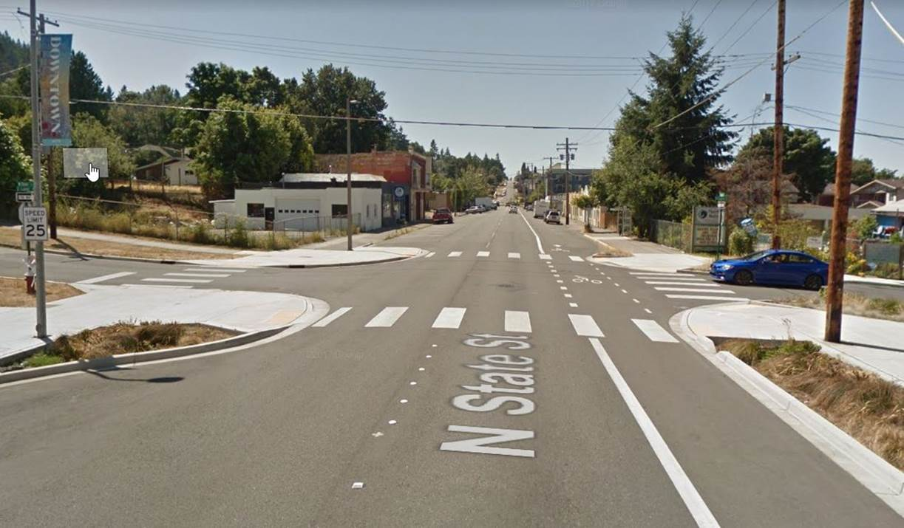Roadway users with disabilities are part of this vulnerable user group. In the first-ever nationwide study of its kind, Kraemer and Benton (2015) found that people using wheelchairs were 36 percent more likely to die when hit by a driver than the general population of people who walk. A number of their findings point to the need for both design and behavioral solutions. The data showed that in 76.4 percent of these crashes, the driver had made no apparent effort to avoid hitting the person using the wheelchair, and almost half of these fatal crashes occurred at intersections where someone might be expected to be crossing the road.

An effectively designed intersection in Bellingham, WA that has curb extensions, ADA ramps, crosswalks and a connection to a nearby trail system.

ATSAC has been intentionally recruiting representatives from these underserved communities so that recommendations can be appropriately informed by current community realities.

**Finding #3 – Impairment increases vulnerability.**

According to the 2019 Target Zero plan, impairment was involved in 61 percent of the crashes from 2015-2017 in which someone who was walking died. Impairment by the driver, or by the person walking, or both was involved in 201 out of 397 deaths. Of the impairment-related deaths, 26 (12.9 percent) involved an impaired driver, 152 (75.6 percent) involved an impaired walker or bicycle rider, and 23 (11.4 percent) involved both an impaired walker or bicycle rider *and* an impaired driver.

**Finding #4 - Roadway crossings are the most common behaviors in fatal and serious injury crashes involving people who walk.**

According to the 2019 Target Zero plan, nearly 58 percent of both fatalities and serious injuries from 2015–2017 occurred when a person walking was crossing the roadway. Other fatalities occurred while a person was walking on the shoulder or in the roadway or while they were working or playing in the roadway. Based on roadway crossing case studies, the PSAC identified a need for traffic control facilities at the types of locations where fatal or serious injury crashes occur.

**Finding #5 - Age and other physical factors increase vulnerability.**

Older adults, children, people with disabilities, and people taking medications like blood thinners are more likely to die or suffer a serious injury when drivers hit them. In many cases, they must rely on walking for transportation due to physical, economic, or legal reasons. Lower-riding vehicles like passenger cars tend to impact people in the lower legs if they are walking, the person who is walking then snaps forward onto the hood of the vehicle. According to King County Medical Examiner Dr. Richard Harruff, a crash with a vehicle like this may be survivable because the person’s body is able to bend over the vehicle, thus displacing some of the force from the crash. However, crashes involving people walking and larger vehicles like sport utility vehicles (SUVs) more often result in the death of the person walking because their body has no place to displace the force of the impact.

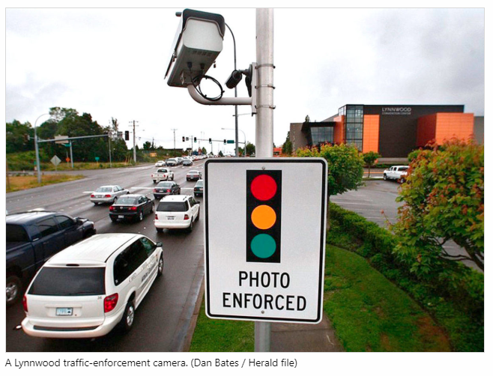**Finding #6 - Automated speed enforcement cameras slow operating speeds.**

State law[2] currently allows the use of automated speed enforcement cameras within school zones. The broadest deployment of automated enforcement is in Seattle. There are currently automated speed enforcement cameras installed at schools. The cameras only operate when the school zone flashing beacons are in operation. The Seattle Department of Transportation sets the flashing beacon operating schedule based on when students will be arriving and leaving school grounds. There has been a marked decline in speeding through those 14 school zones, a reduction in overall crashes, and a reduction in the number of citations issued each year. There have been no collisions with people who walk or ride bicycles near those 14 schools in more than five years. Seattle earmarks revenues from the automated speed enforcement infractions for support of traffic safety improvements such as roundabout installation, traffic calming measures such as chicanes and lane narrowing, and bicycle lane construction. There are currently 16 other Washington cities that utilize automated speed enforcement cameras, red light enforcement cameras, or both.

**Finding #7 - The Washington State Legislature passed necessary legislation to update the state’s vulnerable user law.**

The 2019 Washington State Legislature passed legislation updating the state’s vulnerable user law (RCW 46.61.526) providing confirmation of the disproportionate potential for harm between drivers and vulnerable users. The legislation clarifies what “safe passing” means when it comes to drivers trying to get around people riding bicycles, and establishes a roadway user account to be supported by doubling fines for offenses when people who walk, ride bicycles, or use other forms of active transportation are involved.

**Finding #8 - Infrastructure is key to reducing crashes.**

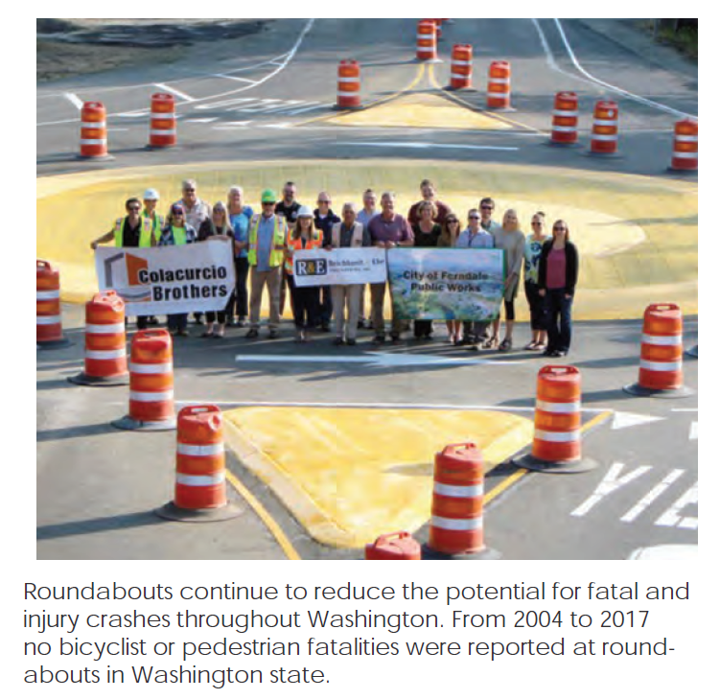Roundabouts cause drivers to slow to 20 mph or less while going through them. Roundabouts are just one infrastructure solution. With downtown or residential streets, it may be more appropriate to calm the traffic with chicanes and lane narrowing.

Roads shared by people driving, walking, and bicycling should feature frequent opportunities to cross the road and should have appropriate separation between modes of travel. The problem often comes down to having fiscal resources to pay for necessary infrastructure improvements, the knowledge and willingness of transportation agencies to apply principles of systematic safety, and community commitment to make changes that save lives.

**Finding #9 - Lack of accurate data about the number of people who walk and the facilities available to them continues to be a problem.**

A chronic shortage of data hampers efforts to effectively plan for – and strategically invest in – a sustainable safety environment. Similar to most states, Washington does not have accurate counts of people who walk, ride bicycles, or use other forms of active transportation. We cannot develop accurate pictures of exposure to potential fatal or serious injury crashes. This is important information because it allows us to determine where crashes might occur and how effective our modifications have been.

**Finding #10 - Actions and contributing factors in crashes.**

Data about crash contributing factors and person actions are not detailed enough on standard crash reports. Frequently, investigating officers must rely on only the driver’s accounts of the incident since the person walking or riding a bicycle is usually deceased at the scene or too seriously injured to be interviewed. The most commonly checked box for contributing factors by investigating law enforcement in a crash involving people who are walking or bicycling is “None Reported” for drivers. That occurs in approximately one-third of these fatality crashes.

**Finding #11 - Transportation infrastructure needs to be improved for safe use of bicycles.**

The majority of crashes between motorists and people riding bicycles occur when the person riding the bicycle is using the general-purpose travel lane rather than a shoulder, separated path, sidewalk, or other facility. According to WSDOT, from 2015-2017, this condition accounted for 41 percent of all crashes between motorists and people riding bicycles overall, but made up nearly 55 percent of the fatal and serious injury crashes involving motorists and people riding bicycles. This information supports wider use of protected bicycle lanes. A central theme in crashes involving motorists and people riding bicycles is that the driver failed to notice the person riding the bicycle.

**Finding #12 - Bicycle infrastructure terminology needs to change on the police form.**

In 2020, the Police Traffic Collision Report (PTCR) will substitute the words “bike lane” for “designated bike route.” In addition, the new PTCR will capture bicycle and pedestrian pavement marking presence. The PSAC and BSAC have discussed other possible changes to the PTCR, but recognize that the priority is to have law enforcement provide more information on the crashes that are investigated so there is better information about contributing factors for the crashes.

# Key Language Use Concepts from BSAC and PSAC Reports

Language shapes our understanding of transportation. The vocabulary used in discussions about traffic safety affects how people view improvements to the transportation system. The following are terms to use to help communicate more clearly and accurately about active transportation issues.

|  |  |
| --- | --- |
| **Use in state law, administrative code, documents, and media communications:** | **Instead of:** |
| **“crash” or “collision”**  These terms are consistent with recommendations from NHTSA, public health practitioners, Associated Press, and others. Crashes and collisions are preventable and their severity can be reduced. | “accident” |
| **“driver,” “motorist,” or “person driving”**  Particularly with the emergence of connected and autonomous vehicles, media coverage official reports should be clear and specific in labeling the actions of the driver rather than the vehicle. | Do not refer to the vehicle as taking actions on its own, e.g., “the car then turned right and proceeded down the road.” |
| **Use in state law, administrative code, documents, and media communications:** | **Instead of:** |
| **“roadway users”**  Using the term “roadway user” purposefully avoids assuming that driving is the norm and all other modes of transportation are alternatives to driving. | “non-motorist” |
| **“bicycling,” “walking,” or “active transportation”**  The term “active transportation” includes walking, bicycling, using a mobility assist device like a wheelchair or walker, or using a small-wheeled device such as a skateboard, foot scooter/e-scooter, or inline skates. Using the term “non-motorized transportation” reinforces the current system priority for use of motorized vehicles. | “non-motorized transportation” or “alternative transportation” |
| **“people walking” or “people who walk”**  Using “people walking” is people-first language and establishes that it is a person doing an action. Pedestrian defines the person by the action. There are, however, all kinds of walking. Where a one-word term better suits the structure of the sentence or discussion, the word “walker” is preferred. | “pedestrians” |
| **“people biking,” “people using bicycles,” or “people who bike”**  Using “people biking” is people-first language and establishes that it is a person doing an action. “Bicyclist,” like “pedestrian,” defines the person by the action; “cyclist” carries this a step further to suggest certain stereotypes about who bicycles and why. Where a one-word term better suits the sentence or discussion, the word “bicyclist” is preferred. | “bicyclist” or “cyclist” |

# Crash Data for People Who Walk or Ride Bicycles: A Deeper Look

In addition to the data about people who walk or ride bicycles available in [Washington’s Strategic Highway Safety Plan 2019, Target Zero](http://wtsc.wa.gov/wp-content/uploads/dlm_uploads/2019/10/TargetZero2019Lo-RES.pdf), the BSAC and PSAC also reviewed other data sources and considered the information gathered through case reviews in developing the recommendations contained in their annual reports.

Data Overview from Target Zero 2019

In 2015–2017, 20 percent of all traffic fatalities and 20 percent of all traffic serious injuries in our state were people walking or biking. At 109 fatalities in 2017, deaths for people who were walking reached their highest number in more than 30 years.

Compared to 2012–2014, the 2015–2017 figures show a 41 percent increase in fatalities for people who walk and bike, and an 11 percent increase in serious injuries. Unfortunately, Washington lacks complete data on the total number of people regularly walking and bicycling, as well as the distance they travel in those modes. Therefore, it is difficult to say whether crashes have increased due to exposure -- more people walking and biking for longer distances -- or whether exposure has remained the same, but crash potential has grown due to other factors. Two potential contributors to the upward trend are the increase in overall vehicle miles traveled in Washington and the increase in larger passenger vehicles such as trucks and SUVs on the road.

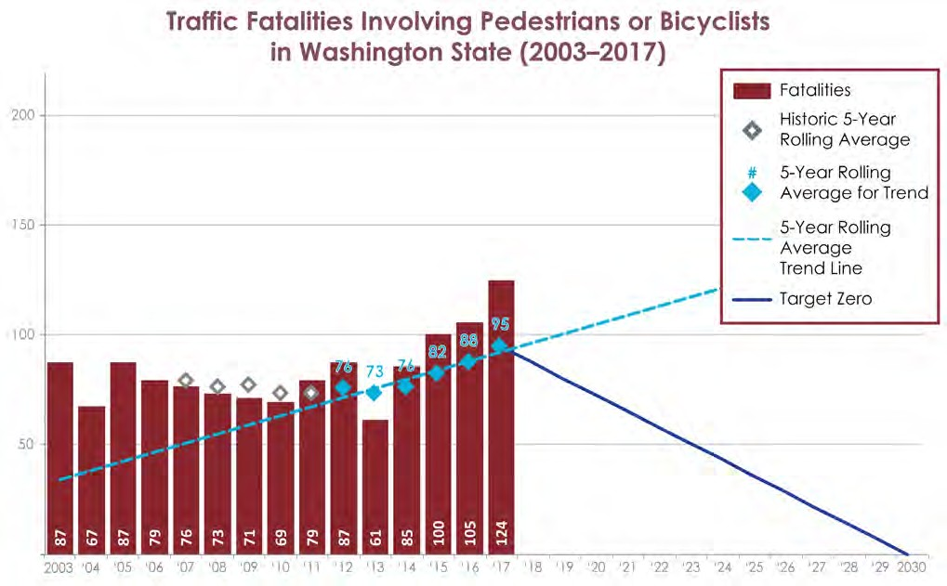

From 2015-2017, 329 people died while walking and riding bicycles on Washington roads and 1,333 more were seriously injured.

Of those crashes:

* 40 percent involved distraction.
* 61 percent involved impairment.

Of the 201 deaths involving impairment and people who were walking or bicycling:

* 26 (12.9 percent) involved only a person who was driving impaired;
* 152 (75.6 percent) involved only a person who was walking or riding a bicycle impaired; and
* 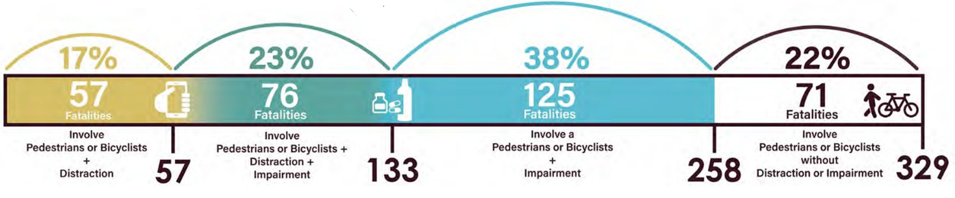23 (11.4 percent) involved both a person who was walking or riding a bicycle impaired *and* a person who was driving impaired.

**Percent of all Fatalities and Serious Injuries that Involved People who Were Walking or Riding Bicycles, by County, (2015-2017)**

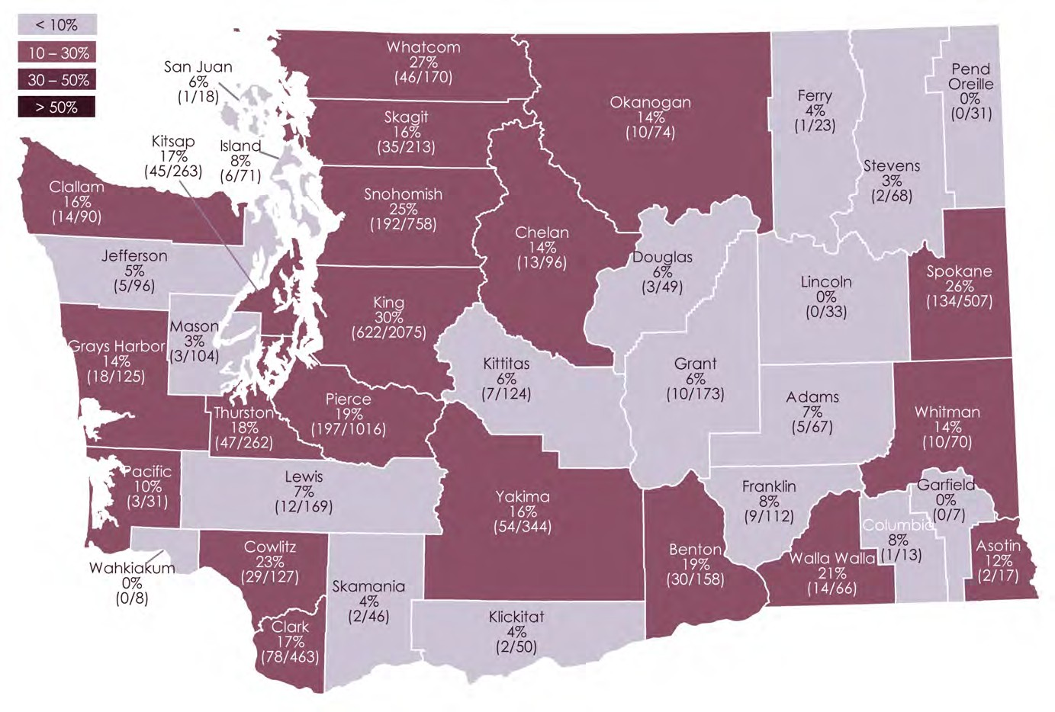

**Contributing Factors from PSAC, BSAC, and Target Zero 2019**

A comprehensive review of all crash data available for the Fatality Analysis Reporting System (FARS) and state crash databases where a PTCR was completed shows:

* A majority of deaths for people who were walking involved impairment of the walker (54.1 percent).
* In fatal crashes involving people who were walking, it was most common in 2015–2017 for there to be no contributing circumstances noted for drivers (38.5 percent). From 2015-2017, there were no contributing circumstances noted in more than 39 percent of the serious injury cases.
* In both fatal and serious injury crashes involving people who were walking, it was most common for the drivers to be going straight (79.9 percent for fatalities, 70.1 percent for serious injuries).
* For both fatalities and serious injuries, more than 57 percent of walkers were crossing the roadway. Serious injury crashes for people who were walking were more likely to occur at intersections (50.4 percent).

**Walker-Related Contributing Factors**

|  |  |
| --- | --- |
|  | = Fatality crashes |
|  | = Serious injury crashes |

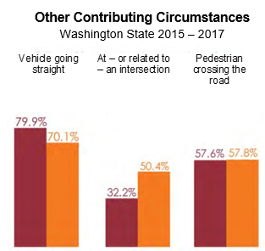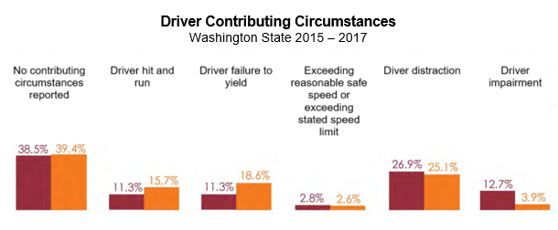

|  |  |
| --- | --- |
|  |  |

**Bicycle Rider-Related Contributing Factors**

For crashes involving people who were riding bicycles, the data show the following:

A majority of deaths for people who were riding bicycles shows that the riders were most commonly going straight (47.8 percent), or turning (23.9 percent), or crossing the roadway (21.5 percent). For serious injury crashes, it was most common for riders to be turning (38.2 percent) or riding against traffic (22.2 percent). For both fatality and serious injury crashes involving people riding bicycles, it was most common for drivers to be going straight on the roadway (78.3 percent for fatalities, 41.5 percent for serious injuries).

|  |  |  |
| --- | --- | --- |
|  | = Fatality crashes |  |
|  | = Serious injury crashes |  |

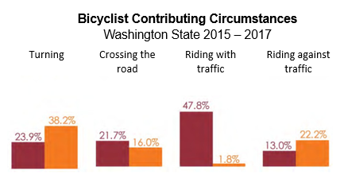

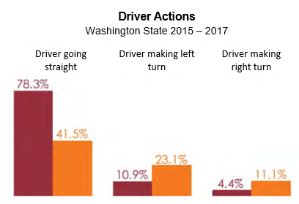

# Appendix A – Cooper Jones Active Transportation Safety Advisory Council Project Charter

Cooper Jones Active Transportation Safety Advisory Council (ATSAC) Project Charter

Update: Revised November 21, 2019

|  |  |
| --- | --- |
| Project Organization | |
| ATSAC Members | Legislatively identified members:   * A coroner from the county in which the most deaths have occurred for people who walk, ride bicycles, or use other forms of active transportation – David Delgado, King County Medical Examiner’s Office * A representative from a bicycle rider or other roadway user advocacy group – Alexandria Alston, WA Bikes * A representative from a walker (pedestrian) advocacy group – Julia Reitan, Feet First * A representative from the Association of Washington Cities – Jon Pascal, Kirkland City Council * A representative from the Department of Health (DOH) – Will Hitchcock * A representative from the WTSC – Darrin Grondel (or designee) * A representative from WSDOT – Barb Chamberlain, WSDOT Active Transportation Division Director * A traffic engineer – Dongho Chang, City of Seattle Traffic Engineer * Multiple members of law enforcement who have investigated fatalities involving people who walk, ride bicycles, or use other forms of active transportation – Paul Taylor, Spokane Police and Eric Edwards, Richland Police * Additionally, the commission may invite a victim or family member of a victim to participate in the council – David Jones * A representative from the Association of Washington Counties – Currently being recruited   Members identified by WTSC:   * A representative from one of Washington’s 29 federally recognized tribes – Portia Shields, Yakama Nation * Asian/Pacific Islander representation – Commission on Asian Pacific American Affairs – Harold Taniguchi * Disability population representative - Anna Zivarts, Rooted in Rights * Traffic engineers - Josh Diekmann, City of Tacoma Transportation Engineer, Katherine Miller, City of Spokane Capital Projects * City Planner - Chris Comeau, City of Bellingham Planner * Legislator or Legislative Staff – Rep. Shelley Kloba * Public Health Practitioners – Jenny Arnold, Spokane Regional Health District, Dr. Amy Person, Benton Franklin Health District * Safe Routes to Schools – Charlotte Claybrooke, Washington State Department of Transportation * Target Zero Managers – Annie Kirk, Region 7 Target Zero Manager and Karen Wigen, Region 16 Target Zero Manager * Transit Representative – Kerri Wilson, Intercity Transit * Advisor: Ryan Peters, NHTSA Region 10   Additional members being recruited:   * African American population representation - * Economic diversity representative – * Elderly population representative – * Hispanic/Latino population representation - |
| Executive Committee  (ATSAC members formed an Executive Committee to guide the organization between meetings.) | **A representative from:**  **A bicycle rider or other roadway user advocacy group** – Alexandria Alston, WA Bikes  **WSDOT** – Barb Chamberlain, WSDOT Active Transportation Division Director  **WTSC** – Darrin Grondel, Director (or designee)  **Department of Health** – Will Hitchcock  A walker (pedestrian) advocacy group – Julia Reitan, Feet First |
| Project Manager  (Designated by WTSC) | WTSC Program Manager - Scott Waller |
| Meeting Facilitator  (Selected by Executive Committee) | Trillium Leadership Consulting - Patricia Hughes |
| Meeting Dates and Locations  (Set by ATSAC group) | 9/18/2019 – Seattle; 11/20/2019 – Seattle; 1/15/2020 – Spokane; 3/18/2020 – Seattle; 4/28/2010 – Spokane (In conjunction with Washington Walk, Bike, and Roll Summit); 7/15/2020 – Seattle; 9/16/2020 – Seattle; 11/18/2020 – Seattle; 1/20/2021 – Seattle; 3/17/2021 – Spokane; 5/19/2021 - Seattle |

|  |  |
| --- | --- |
| ATSAC Description | In 2019, the Washington State Legislature passed Substitute Senate Bill 5710, which creates the Cooper Jones Active Transportation Safety Advisory Council (ATSAC). The purpose of the council is to review and analyze data to identify patterns and programs related to fatalities and serious injuries involving for people who walk, ride bicycles, or use other forms of active transportation to identify points at which the transportation system can be improved including, whenever possible, privately owned areas of the system such as parking lots.  The council may also:  (a) Monitor progress on implementation of existing recommendations from the Pedestrian Safety Advisory Council and Cooper Jones Bicyclist Safety Advisory Council. (Both groups ended on June 30, 2019).  (b) Seek opportunities to expand consideration and implementation of the principles of systematic safety, including areas where data collection may need improvement. |
| Timeframe | The Legislature placed no sunset provision in the enabling legislation. |
| Mission  (Set by ATSAC group based on language from SB 5710) | Increase safety for people who walk, ride bicycles, or use other forms of active transportation in Washington State to reduce – and eventually eliminate - fatalities and serious injuries in Washington. |
| Objectives  (Set by ATSAC group based on language from SB 5710) | * Support and enhance existing and pending transportation safety efforts such as The Washington State Strategic Highway Safety Plan (Target Zero Plan) and Active Transportation Plan that aims to reduce and eventually eliminate transportation-related fatalities and serious injuries involving people who walk, ride bicycles, or use other forms of active transportation in Washington State. * Using a data-driven approach, make recommendations regarding changes in statutes, ordinances, rules, and policies to improve safety for people who walk, ride bicycles, or use other forms of active transportation. |
| Approach  (Set by ATSAC group based on language from SB 5710) | * Use data to inform our understanding of contributing factors of collisions involving people who walk, ride bicycles, or use other forms of active transportation and current countermeasures utilized to address them. * Evaluate existing data, identify and address gaps affecting safety for people who walk, ride bicycles, or use other forms of active transportation. * Leverage existing programs and strategies, e.g., incorporation of safety for people who walk, ride bicycles, or use other forms of active transportation in comprehensive planning and capital facility planning. * Incorporate review of equity, access, and social justice considerations into all discussions about recommendations. * Recommend systematic and operational changes in how safety for people who walk, ride bicycles, or use other forms of active transportation is addressed in Washington: Engineering, Education, Encouragement, Enforcement, EMS, Evaluation, and Policy (i.e. legislative changes). |
| Project Roles  (Set by ATSAC group based on language from SB 5710) | * The Governor will review and provide final approval of the report. * Executive Committee will provide operational direction to the Project Manager, including areas such as project scope, budget, schedule, and group membership. They will approve the report prior to sending it to the project manager.   The Project Manager will work with the Executive Committee to design the steps to implement the ATSAC, determine meeting agendas and facilitation strategies, provide meeting recaps to members and stakeholders, manage costs, and provide all required reports and documentation.   * The Data Analyst will provide requested data to the ATSAC. * ATSAC Members will approve and follow the project charter; request data as needed, discuss issues, draft comments and provide the Project Manager with feedback for the reports, and recommend final report approval for WTSC. * Stakeholders (all interested parties) will be kept informed of the ATSAC activities and project status, report structure and content, and will be provided opportunity to submit input. |

|  |  |
| --- | --- |
| Scope, Assumptions, Constraints, and Acceptance Criteria | |
| Project Scope  (Set by ATSAC group based on language from SB 5710) | In scope:   * Produce an annual Cooper Jones Active Transportation Safety Advisory Council report by December 31 of each year beginning in 2019. Ensure appropriate stakeholders are involved and informed throughout the process. * Report any budgetary or fiscal recommendations to the Office of Financial Management/Legislature by August 1 each year. * Evaluate ATSAC process throughout the project and adjust the work plan as needed. * Document the ATSAC activities and report creation to allow for future replication and process improvement.   Out of scope:   * Reports and actions not authorized within SSB 5710. * Expenditures that are beyond the amount allocated by the legislature to WTSC for operation of the ATSAC. |
| Project Scope: Changes | Executive Committee must approve scope changes. |
| Assumptions | * ATSAC members will be available and able to complete the work needed to write the reports. * The Project Manager will have adequate time to devote to the management of this project. * ATSAC members will have adequate time to devote to the project. * ATSAC, WTSC, partner agencies, and the Governor’s Office can approve the report within the required timeframe for delivery. * WTSC has funding appropriated by the legislature to support travel by ATSAC members to travel to/from meetings. |
| Constraints | * There is limited funding for a Program Manager to perform the functions needed for project success. * The ATSAC will be organized differently than its predecessor organizations (PSAC and BSAC) and it may take a while to figure out how everything works best. * There will be a mix of individuals who have participated on the PSAC or BSAC and individuals who have not. As a result, it may take a while for the group to develop a cohesive identity. |

|  |  |
| --- | --- |
| Project Requirements  (Set by ATSAC group based on language from SB 5710) | Report Acceptance Criteria. The annual reports must be structured and written to:   * Fulfill the requirements of SB 5710. * Provide an analysis of fatalities and serious injuries involving people who walk, ride bicycles, or use other forms of active transportation. * Make recommendations for action by WTSC, other state agencies, the Governor’s Office, and the Legislature to increase safety for people who walk, ride bicycles, or use other forms of active transportation. * Inform future revisions of the Target Zero Plan (WTSC) and Active Transportation Plan (WSDOT). * Demonstrate clear goals and pathways to implementation for all recommendations. * Support other independent, agency, or jurisdiction efforts. * Develop a biennial report on budgetary or fiscal recommendations to the Office of Financial Management. * Provide ongoing documentation to continue and improve this project. * Stakeholder Satisfaction: Although stakeholder satisfaction is critical to the success of the ATSAC, it is not expected that every stakeholder will be completely satisfied with the report. The Project Manager will keep the Executive Committee aware of any risks associated with stakeholder dissatisfaction. |

# Confidentiality Statement

Per RCW 43.59.155(6)(a) information and documents prepared by or for the council are inadmissible and may not be used in a civil or administrative proceeding. Confidential information is not disclosable. No person in attendance at meetings of the council nor persons who participated in the compiling of information or documents specifically for the WTSC or council shall be permitted to testify in any civil action as to the content of such meetings, information, or documents specific to the activities of the council.

1. Dooring is a traffic collision or crash in which a bicycle rider (or other road user) rides into a motor vehicle's door, swerves to avoid, or is struck by a door that was opened quickly by an occupant who failed to check carefully for approaching traffic.
2. RCW 46.63.170