Cooper Jones Active Transportation Safety Council (ATSC)
Revised July 2023

Project Organization
Executive Committee | - Transportation: Barb Chamberlain, Washington State Dept. of Transportation (WSDOT)  - Bicyclist Rep: Alex Alston, Washington Bikes  - Public Health: Dr. Amy Pearson, Department of Health  - Pedestrian Representative:  - Jessie Knudsen, Washington Traffic Safety Commission, Project Mgr.  - Shelly Baldwin, Washington Traffic Safety Commission, Director
Staff | Jessie Knudsen - Program Manager, WTSC
Voting Members | Legislature-identified members:  - WTSC Representative  - County Coroner employed in a location where pedestrian, bicyclist, or non-motorist deaths have occurred  - Law enforcement members with experience investigating pedestrian, bicyclist, or non-motorist fatalities  - Traffic engineer  - WSDOT representative  - Association of Washington Cities representative  - Washington State Association of Counties representative  - Pedestrian advocacy group representative  - Bicycle or active transportation advocacy group representative  - Department of Health representative  - Victim/victim’s family member  ATSC-identified members:  - Washington State Comm. on African American Affairs representative  - Tribal representative  - Asian/Pacific Islander representative  - City planner  - Disability population representative  - Economic diversity representative  - Senior citizen representative  - WA State Comm. on Hispanic Affairs representative  - Legislator or legislative staff  - Safe Routes to School program representative  - Target Zero Manager(s)  - Public Transit representative  - Unhoused Services representative  - Emergency Medical Service representative
Facilitator | Patricia Hughes, Trillium Leadership Consulting LLC.
Data Analyst | Dr. Max Roberts, Research Associate, WTSC

Council Meeting Operations
Monthly council meetings are open to the public and subject to the Open Public Meetings Act (OPMA), 42.30 RCW. Regular council meetings are hosted on Zoom, the third Wednesday of each month or at such other place named by the WTSC. The meeting link, scheduling information and summary notes are accessible to the public at www.wtsc.wa.gov/programs-priorities/active-transportation-safety-council.

Council Funding Decision Making Process
As the Council has opportunities to recommend use of funds from safety camera and other revenue sources, it will use the following criteria to determine where and how to spend those funds. Funding will:
- Fit the stated purpose of ATSC
- Fit within the critical criteria as adopted by ATSC in January 2020
- Fit the equity approach as adopted by ATSC in January 2020
- Have a statewide benefit
- Build on past ATSC recommendations
- Process: ATSC as a whole will consider and recommend potential funding uses, then a small team will develop a proposal to bring to the whole committee for discussion and vote

Membership
When any number of the eleven legislature-identified council positions become vacant, the Executive Committee and Council staff will identify new members to fulfill the roles. Additional representation roles may be identified by council members to diversify perspectives.

Voting
To conduct council business (voting), a quorum is required. A quorum consists of the majority of all voting members (regardless of whether or not they are present at the meeting). All council members are voting members.

Revisions to the Charter
Changes to the charter must be reviewed by the Executive Committee prior to being made by WTSC.

Description, Timeframe, Mission, Objectives, Approaches, Roles, and Requirements
Description | In 2019, the Washington State Legislature passed Substitute Senate Bill 5710, which required the WTSC to convene the Cooper Jones Active Transportation Safety Council (ATSC), governed by RCW 43.59.156.  The council's purpose is to use data to identify patterns related to fatalities and serious injuries involving bicyclists, walkers, and all other active transportation users, with the goal of identifying transportation system improvements, including privately owned areas, such as parking lots.  In addition, the council may:  (a) Monitor implementation progress of ATSC recommendations.  (b) Seek opportunities to expand consideration and implementation of the principles of systematic safety, including data collection improvement.
Timeframe | The Legislature placed no sunset provision in the enabling legislation.
Mission | Increase safety for bicyclists, walkers, or users of other forms of active transportation in Washington State.
Objectives | - Support and enhance efforts to reduce and eliminate fatalities and serious injuries of bicyclists, walkers, and other active transportation users, such as the Washington State Strategic Highway Safety Plan (i.e., Target Zero Plan) and the WSDOT Active Transportation Plan.  - Improve safety by providing data-driven recommendations regarding statutes, ordinances, rules, and policies.
Approach | - Use data to identify countermeasures to address and factors contributing to collisions that involve people using active transportation.  - Evaluate existing data to identify and address data gaps related to bicyclist, pedestrian, and other active transportation user safety.  - Leverage existing programs and strategies, e.g., incorporation of safety for bicyclists, pedestrians and active transportation users in comprehensive planning and capital facility planning.  - Recommend systematic and redundant changes to increase safety for people who walk, ride, and roll, considering the principles and objectives of the Safe System Approach.  - Washington Statutory Definition: RCW 47.04.010 https://app.leg.wa.gov/rcw/default.aspx?cite=47.04&full=true#47.04.010  - Link to federal site: https://www.transportation.gov/NRSS/SafeSystem  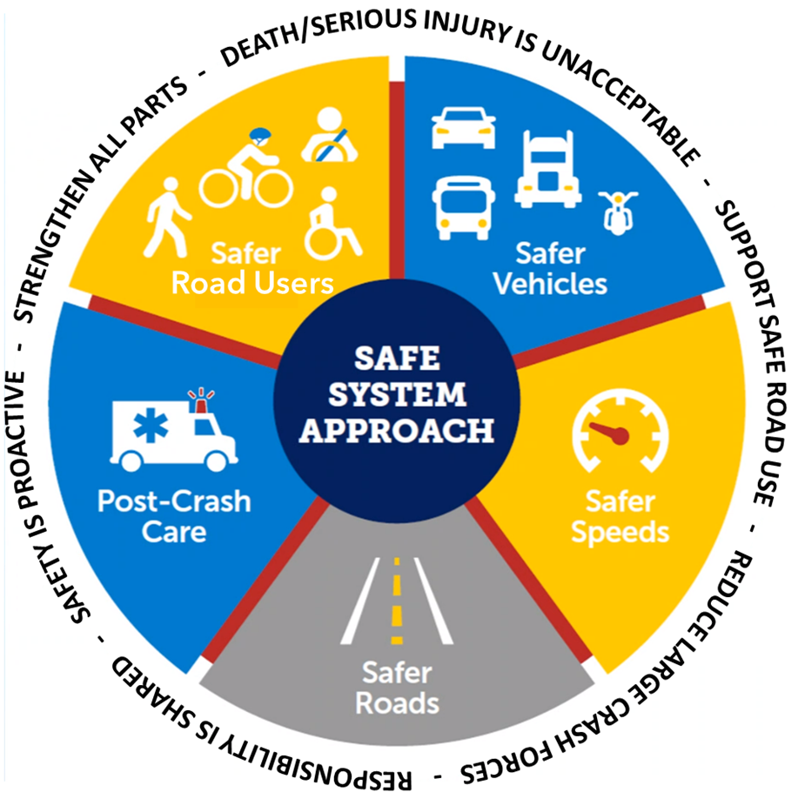
Roles | - Governor’s office, provide final approval of the report.  - Washington Traffic Safety Commission, chartering authority. The Director or their designee will chair meetings. The WTSC will provide staff and seek council input regarding how Cooper Jones Active Transportation Safety account funds are spent.  - Executive Committee, provide operational direction to the WTSC project manager, including project scope, budget, schedule, and membership, and approve the annual report prior to finalization.  - Project Manager, work with the Executive Committee and facilitator to implement council goals, compile agendas and summaries, identify facilitation strategies, manage the annual budget, ensure compliance with the OPMA, and produce required reports and documents.  - Data Analyst, provide requested data to the ATSC.  - ATSC Members, approve and follow the project charter, vote to take action, when necessary, make data requests, participate in discussions, draft comments, and provide council staff with recommendations.  - Stakeholders, submit feedback and stay informed of council activities, projects, and reports.  - Facilitator, create agendas for Executive Committee and Council meetings, compile minutes, facilitate meetings, compile reports, and provide support to sub-committees and council staff as needed.
Requirements | - Annual Report Acceptance Criteria  - Fulfill the requirements of SB 5710.  - Provide an analysis of fatalities and serious injuries involving bicyclists, pedestrians, and other active transportation users.  - Make recommendations for actions to increase pedestrian, bicyclist and active transportation user safety to the WTSC, state agencies, the Governor’s Office, and the Washington State Legislature.  - Inform the WSTC Target Zero Plan, WSDOT Active Transportation Plan.  - Demonstrate clear goals and pathways to implement recommendations.  - Support other independent, agency, or jurisdiction efforts.  - Develop a biennial report on budgetary and fiscal recommendations to the Office of Financial Management (OFM).  - Provide the documentation necessary to continue and improve project.
 | Budget: The WTSC is authorized to spend the budgeted amount in support of activities authorized by the Executive Committee. Any expenditure beyond that must be authorized by the State Legislature.
 | Stakeholder Satisfaction: Although stakeholder satisfaction is critical to the success of the ATSC, it is expected that not every stakeholder will be completely satisfied with the report. Council staff will keep the Executive Committee aware of any risks associated with stakeholder dissatisfaction.
Project Scope, Acceptance Criteria, Assumptions, and Constraints
Scope | In:  - Produce an annual report by December 31. Ensure appropriate stakeholders are involved and informed throughout the process.  - Annually report budgetary and fiscal recommendations to the OFM and the legislature by August 1.  - Evaluate ATSC project process and adjust the work plan as needed.  - Document council activities and reports to allow for replication and process improvement.  Out:  - Reports and actions not authorized by SSB 5710.  - Expenditures beyond those authorized by the legislature for operation.
Changes | Scope changes must be approved by the Executive Committee.
Assumptions | - ATSC members will be available to help write and edit annual reports.  - Council staff will devote adequate time to project management.  - ATSC members will devote adequate time to the project.  - ATSC, WTSC, partner agencies, and the Governor’s Office will approve the annual report within the required timeframe.  - Funding is appropriated to WTSC by the legislature to support council member travel to/from meetings when scheduled in-person.
Constraints | - Limited resources for project staff to perform project functions necessary for success.

