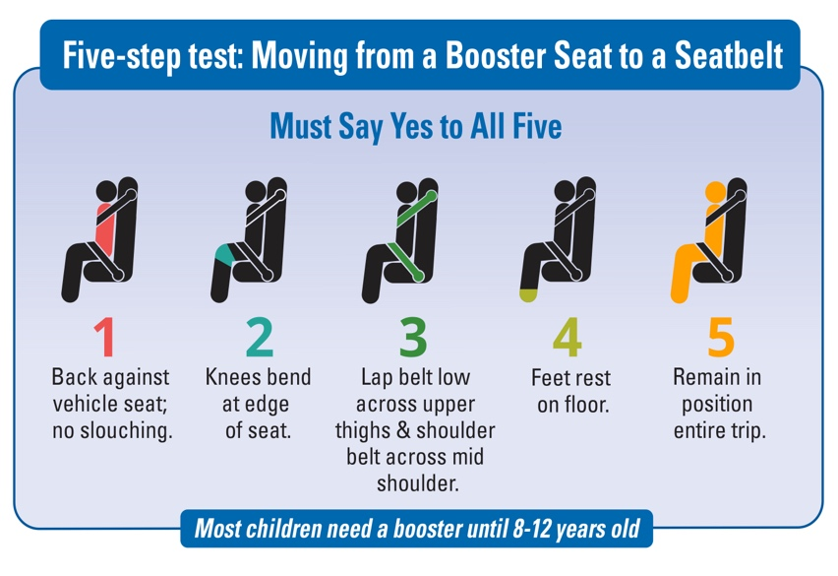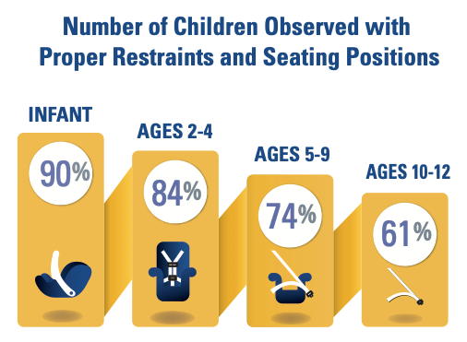For more information, visit www.wacarseats.com

Your child’s school is partnering with your local Child Passenger Safety Technicians to help protect your child from serious injury and death in a car crash.

Recent statewide observational surveys in Washington State showed compliance with child restraint requirements decreases as children get older.

**Everyone is Safer in the Back Seat-Especially Kids!**

Kids under the age of 13 riding in the front seat are 50% more likely to be killed or seriously injured in a vehicle crash than those riding in the back seat.

**It’s What’s on the Inside That Counts!**

It’s not about the size and weight, it’s about bone strength and body structure. Until age 13, kids’ bodies aren’t strong enough to withstand crash forces in the front seat.

**Boosters Provide Proper Placement of the Seat Belt!**

Studies show that using a booster seat can reduce risk of injury in a crash by 45 percent over a seat belt alone.

**It’s the law!** (RCW 461.61.687)

* 0 – 2 years = rear-facing car seat
* 2 – 4 years = car seat with harness
* 4 years and older = booster until 4’9” tall
* Up to age 13, ride in back seat

**The Safest Ride**

Is your child riding safely in the car?

Be sure kids under age 13 ride in the back seat and in booster seats until 4’9” tall.

**It’s the law (RCW 46.61.687).**